CORE DATA STRATEGY
&
SOLUTIONS ARCHITECTURE

Real-Time Transaction Intelligence from Device to Cloud
AI-Powered Merchant Insights Platform

CONFIDENTIAL

Strategy & Solutions Document | February 2026 | Version 2.0

TABLE OF CONTENTS

1. Executive Summary
2. Business Context & Strategic Rationale
3. Payment Device Hardware & Form Factors
4. Terminal Operating System & Software Stack
5. On-Device Data Capture Mechanism
6. Edge-to-Cloud Data Transmission
7. Cloud Data Platform Architecture
8. Data Anonymization & Privacy Engine
9. Real-Time Data Pipeline (End-to-End Flow)
10. AI Agent Deployment Strategy
11. Merchant Use Cases & Value Delivery
12. Data Products & Monetization
13. Implementation Roadmap
14. Governance, Compliance & Risk
15. Success Metrics & KPIs
16. Conclusion & Next Steps

1. Executive Summary
This document presents a comprehensive strategy and solutions architecture for capturing, anonymizing, and leveraging the rich transactional data generated across our integrated payments ecosystem. It covers the full technology stack—from the payment terminal hardware and its embedded operating system, through the POS software integration layer, to the cloud data platform and AI agent deployment.
As a payments company embedded in merchant POS platforms with cloud-managed payment terminals, we occupy a unique position at the intersection of consumer purchasing behavior, merchant operations, payment instrument trends, and device telemetry. This document details exactly how data flows from the moment a consumer taps, inserts, or swipes their card, through the terminal OS and POS software layers, across the encrypted edge-to-cloud transmission path, into our real-time processing and anonymization pipeline, and ultimately into the hands of merchants as AI-driven intelligence.
The strategy addresses three solution pillars: the device and software stack that captures data in real time, the cloud platform that anonymizes and processes it at scale, and the AI agents that transform it into actionable merchant insights across use cases ranging from demand forecasting and dynamic pricing to fraud detection and natural language business analytics.

2. Business Context & Strategic Rationale

2.1 Our Converged Data Position
Our payments infrastructure creates a distinctive data advantage that no single actor in the commerce ecosystem can replicate. Card networks such as Visa and Mastercard see financial authorization data but lack visibility into what the consumer purchased. POS software vendors see the product catalog and basket composition but have limited insight into payment instrument behavior across merchants. We sit at the convergence point, with simultaneous access to both the financial transaction and the product-level basket data, enriched by merchant context and device telemetry from our cloud device management platform.
This converged view—payment instrument, basket contents, merchant profile, location, time, and device state—captured in real time across thousands of merchant locations, constitutes a data asset of exceptional strategic value.

2.2 Strategic Objectives
- Build the Data Foundation: Instrument every layer of the device and software stack to capture comprehensive, high-quality transaction data in real time.
- Ensure Privacy by Design: Implement anonymization at the earliest possible point in the pipeline, ensuring no personally identifiable information enters the analytics layer.
- Create Cross-Merchant Intelligence: Aggregate anonymized data across our merchant base to generate insights that transcend any individual merchant’s visibility.
- Deploy AI Agents: Build purpose-built AI agents that continuously synthesize data and deliver actionable recommendations to merchants.
- Monetize Responsibly: Package data insights into tiered products that generate recurring revenue while deepening merchant engagement.

3. Payment Device Hardware & Form Factors

3.1 Terminal Architecture
The payment terminal is the foundational data collection point in our ecosystem. Modern payment terminals are purpose-built computing devices with specialized hardware components for secure payment acceptance. Understanding the hardware layer is critical because it determines what data can be captured, how quickly, and at what level of security.

3.2 Hardware Components
Each terminal in our fleet contains the following core hardware subsystems:
Component | Function | Data Generated
NFC/CTLS Antenna | Reads contactless cards and mobile wallets (Apple Pay, Google Pay) via near-field communication | Contactless indicator, wallet type, card network, AID
EMV Chip Reader | Reads ICC chip on inserted cards; performs EMV L2 processing for card authentication | Card type, issuer, entry mode, cryptogram
MSR (Mag Stripe) | Reads magnetic stripe on swiped cards; legacy fallback | Track data (encrypted), entry mode flag
Secure Element / HSM | Hardware security module for cryptographic key storage and P2PE | Encryption status, key identifiers
Network Module | LTE cellular, WiFi, or Ethernet connectivity for cloud communication | Connection type, signal strength, latency
Processor / SoC | Main application processor running terminal OS and payment apps | Performance metrics, memory utilization
Display & Peripherals | Touchscreen, printer, barcode scanner, PIN pad | Interaction mode, peripheral status

3.3 Form Factors
Our device fleet spans multiple form factors, each with specific data capture characteristics. Countertop terminals are fixed-location devices connected via Ethernet or WiFi, providing stable, high-throughput data transmission and precise location anchoring. Mobile/portable terminals use cellular or Bluetooth connectivity and capture GPS-based location data, enabling location-aware analytics. Integrated PIN pads are tethered to POS systems and inherit basket data directly through a tight integration layer. Unattended terminals (kiosks, vending, parking) operate autonomously and generate high-frequency, low-basket-complexity transactions with strong temporal patterns.

4. Terminal Operating System & Software Stack

4.1 OS Architecture
The terminal operating system is the software layer that bridges the hardware components and the payment application logic. It is the critical control point for data capture, as it mediates all interactions between the card reader hardware, the payment processing kernel, the POS integration bridge, and the cloud communication channel.
The OS is structured in the following layers, from lowest to highest:
OS Layer | Components | Role in Data Capture
Hardware Abstraction | Drivers for NFC, EMV, MSR, HSM, network, display, peripherals | Exposes raw card read events and device status to upper layers
Security Layer | P2PE encryption engine, key management, secure boot, tamper detection | Encrypts sensitive data at the earliest point; ensures data integrity
Payment Kernel | EMV Level 2 contact, Level 3 contactless processing, authorization request building | Produces structured transaction records: amount, currency, auth code, response code, AID, entry mode
Application Runtime | Execution environment for payment apps, POS bridge, and data capture agent | Hosts the Data Capture Module that assembles unified transaction events
Device Agent | Cloud device management client; handles OTA updates, config push, telemetry | Transmits terminal health data, firmware version, uptime, connectivity to cloud
Communication Layer | TLS/mTLS client, store-and-forward queue, compression, retry logic | Ensures reliable delivery of events to cloud; handles offline buffering

4.2 Payment Processing Flow within the OS
When a consumer presents a payment instrument, the OS orchestrates a precise sequence of operations. The hardware abstraction layer detects the card presence (tap, insert, or swipe) and surfaces a card read event to the security layer. The security layer immediately encrypts the primary account number (PAN) using point-to-point encryption (P2PE), ensuring that the raw PAN is never exposed to any software layer above. The encrypted card data, along with the entry mode indicator, is passed to the payment kernel.
The payment kernel performs EMV processing—selecting the application, authenticating the card, constructing the authorization request, and communicating with the payment host. Upon receiving the authorization response, the kernel produces a structured transaction record containing the amount, currency, authorization code, response code, card type, network identifier, and entry mode. This record is the primary data artifact of the payment flow.
The Data Capture Module operates as a listener within the application runtime. It receives a copy of the transaction record from the payment kernel—already stripped of raw PAN data by the security layer—and enriches it with basket data from the POS bridge, merchant metadata from the device agent configuration, and a precision timestamp from the system clock.

5. On-Device Data Capture Mechanism

5.1 The Data Capture Module
The Data Capture Module is a dedicated software component within the terminal OS application runtime, purpose-built to assemble a comprehensive, unified transaction event by collecting data from three internal sources: the payment kernel (financial transaction data), the POS API bridge (basket and SKU-level data), and the device agent (merchant profile and terminal metadata).
The module operates on an event-driven model. When the payment kernel completes a transaction, it emits a transaction completion event. The Data Capture Module subscribes to this event and immediately begins composing the unified transaction record.

5.2 Data Elements Captured
Category | Data Element | Source | Privacy Treatment
Transaction | Amount, currency, auth code, response code, settlement status | Payment Kernel | Binned/rounded for aggregate analytics
Instrument | Card type (credit/debit), network (Visa/MC/Amex), entry mode (chip/NFC/swipe) | Payment Kernel + Security | Category-level only; no card details
Mobile Wallet | Apple Pay, Google Pay, Samsung Pay indicator | NFC subsystem | Wallet type flag only
Basket / SKU | Item descriptions, quantities, unit prices, discounts, tax, product categories | POS API Bridge | Product-level; no consumer linkage
Merchant | Merchant ID, MCC code, store name, location (lat/long), terminal ID | Device Agent config | Location generalized to postal code for aggregate
Temporal | Timestamp (UTC + local TZ), day of week, time-of-day bucket | System clock | Time bucketed for aggregate analytics
Cardholder | Irreversible PAN token (P2PE), hashed cardholder reference | Security Layer | Irreversible tokenization at device; never raw
Device | Firmware version, OS version, battery, connectivity type/strength, uptime | Device Agent | Operational data; no privacy concern

5.3 POS Software Integration
The POS API Bridge is the critical integration component that enriches the financial transaction record with product-level basket data. Our terminals integrate with merchant POS software platforms through a standardized API that receives the basket payload at the time of payment. This API supports multiple integration patterns: direct socket connection for tightly coupled POS systems, REST API for cloud-based POS platforms, and file-based exchange for legacy systems.
When the POS initiates a payment request, it sends the basket payload—containing individual line items with SKU identifiers, product descriptions, quantities, unit prices, applied discounts, and tax amounts—to the terminal via the POS API Bridge. The Data Capture Module merges this basket payload with the payment kernel’s transaction record, creating a single unified event that carries both the financial and product dimensions of the sale.

5.4 Local Buffering & Store-and-Forward
The Data Capture Module writes each unified event to a secure local buffer (encrypted at rest) on the terminal’s storage. This store-and-forward design ensures data is never lost due to transient network outages. The buffer operates as a persistent queue: events are dequeued and transmitted to the cloud only after receiving an acknowledgment. In offline scenarios, the buffer can retain events for up to 72 hours, automatically transmitting the backlog upon reconnection.

6. Edge-to-Cloud Data Transmission

6.1 Device-to-Cloud Architecture Overview
The following diagram illustrates the complete architecture from the payment device hardware and OS layers through the cloud data platform, showing how data is captured at each layer and transmitted to the cloud for processing:

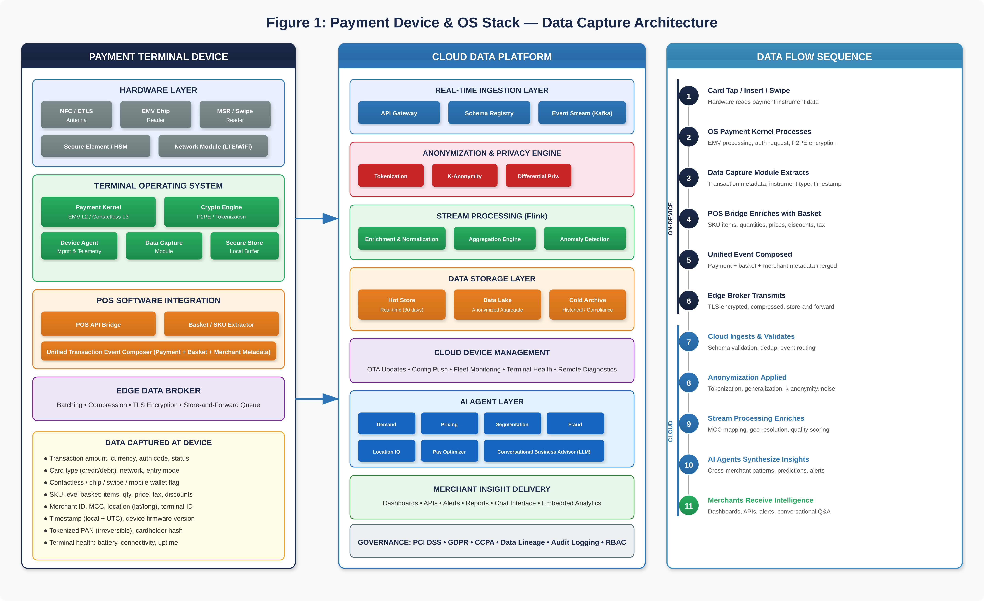
Figure 1: Payment Device & OS Stack — Data Capture Architecture

6.2 Transmission Protocol
The Edge Data Broker on the terminal handles the secure transmission of unified transaction events to the cloud. Every transmission uses TLS 1.3 with mutual authentication (mTLS), where the terminal presents a device certificate provisioned during manufacturing and the cloud endpoint presents its server certificate. This ensures both the identity of the device and the integrity of the data in transit.
Events are batched into micro-batches (configurable from 1 to 50 events per batch, with a default maximum latency window of 5 seconds). Each batch is compressed using LZ4 for bandwidth efficiency and transmitted to the cloud API Gateway. The gateway validates the device certificate, checks the schema version, and routes the batch to the appropriate Kafka topic for downstream processing.
In degraded network conditions, the Edge Data Broker implements exponential backoff with jitter, automatic failover between WiFi and cellular interfaces (where available), and bandwidth-aware compression tuning. Connection health metrics are reported to the cloud device management platform for fleet-wide network quality monitoring.

7. Cloud Data Platform Architecture

7.1 Platform Components
The cloud data platform receives, processes, stores, and serves transaction data and derived insights. It is designed as an event-driven, streaming-first architecture optimized for sub-second latency from ingestion to insight delivery.
- API Gateway & Ingestion: The cloud API Gateway terminates mTLS connections from terminals, validates device identity, performs schema validation against the registry, and publishes validated events to partitioned Kafka topics. Events are partitioned by merchant ID and region to enable locality-aware processing.
- Schema Registry: A centralized schema registry enforces backward-compatible evolution of the transaction event schema. Every event carries a schema version identifier, and the ingestion layer rejects events with unknown schema versions, routing them to a dead-letter topic for investigation.
- Stream Processing (Apache Flink): The Flink cluster performs real-time enrichment (MCC code mapping, geo-resolution, product taxonomy normalization), data quality scoring, windowed aggregations (15-minute, hourly, daily), and real-time anomaly detection. Flink jobs operate on the raw event stream and produce both enriched individual events and pre-aggregated metrics.
- Storage Layer: A three-tier storage model separates hot storage (last 30 days, sub-second query latency in a real-time OLAP engine), the anonymized data lake (historical aggregates in columnar format for batch analytics and ML model training), and cold archive (full event history for compliance and audit purposes, encrypted at rest with customer-managed keys).
- Device Management Integration: The cloud device management platform provides the control plane for the terminal fleet. It pushes configuration updates, firmware OTA packages, and data capture policy changes to terminals. It receives device telemetry (health, connectivity, performance) and correlates it with transaction data quality metrics to identify devices with degraded data capture.

8. Data Anonymization & Privacy Engine

8.1 Privacy-by-Design Architecture
Privacy is a foundational design principle, not a compliance afterthought. Our anonymization strategy ensures no individual consumer can be re-identified from analytics datasets while preserving statistical utility for merchant-facing insights. The anonymization engine operates as a dedicated processing stage in the Flink pipeline, positioned immediately after ingestion validation and before any data reaches the analytics storage or AI layers.

8.2 Anonymization Techniques Applied
- On-Device Tokenization (Pre-Cloud): The PAN is irreversibly tokenized at the terminal security layer using P2PE before it ever leaves the device. Our cloud systems never receive raw card data. The token is a non-reversible hash that serves only as a transaction correlation key and carries no intrinsic cardholder value.
- Generalization: Transaction locations are generalized from precise lat/long coordinates to census tract or postal code level. Timestamps are bucketed into configurable time windows. Transaction amounts are binned into ranges for aggregate analysis.
- K-Anonymity (k ≥ 50): Before any record enters the cross-merchant data lake, we enforce k-anonymity, ensuring every combination of quasi-identifiers maps to at least 50 records. Records that cannot meet this threshold are suppressed.
- L-Diversity: Within each equivalence class, l-diversity ensures sufficient variance in sensitive attributes to prevent attribute inference attacks.
- Differential Privacy: For aggregate statistics, trend reports, and AI training datasets, calibrated Laplacian noise is injected using epsilon-bounded differential privacy mechanisms, providing mathematical guarantees against reconstruction.
- Suppression: Low-volume merchants, rare transaction types, or attribute combinations that risk indirect identification are suppressed entirely from cross-merchant datasets.

8.3 Dual-Path Data Isolation
A strict separation exists between merchant-proprietary data and the anonymized aggregate data lake. Each merchant’s own transaction data remains accessible in full granularity within a tenant-isolated environment. The anonymized data lake contains only data that has passed through the complete anonymization pipeline. No raw or merchant-identifiable data ever enters the aggregate analytics layer. This dual-path architecture is depicted in Figure 2 below.

9. Real-Time Data Pipeline (End-to-End Flow)

9.1 Pipeline Architecture
The following diagram shows the end-to-end data flow from the three source systems (payment terminal, POS software, device management) through the edge composition layer, cloud ingestion, anonymization, stream processing, storage, AI agent layer, and merchant delivery channels:

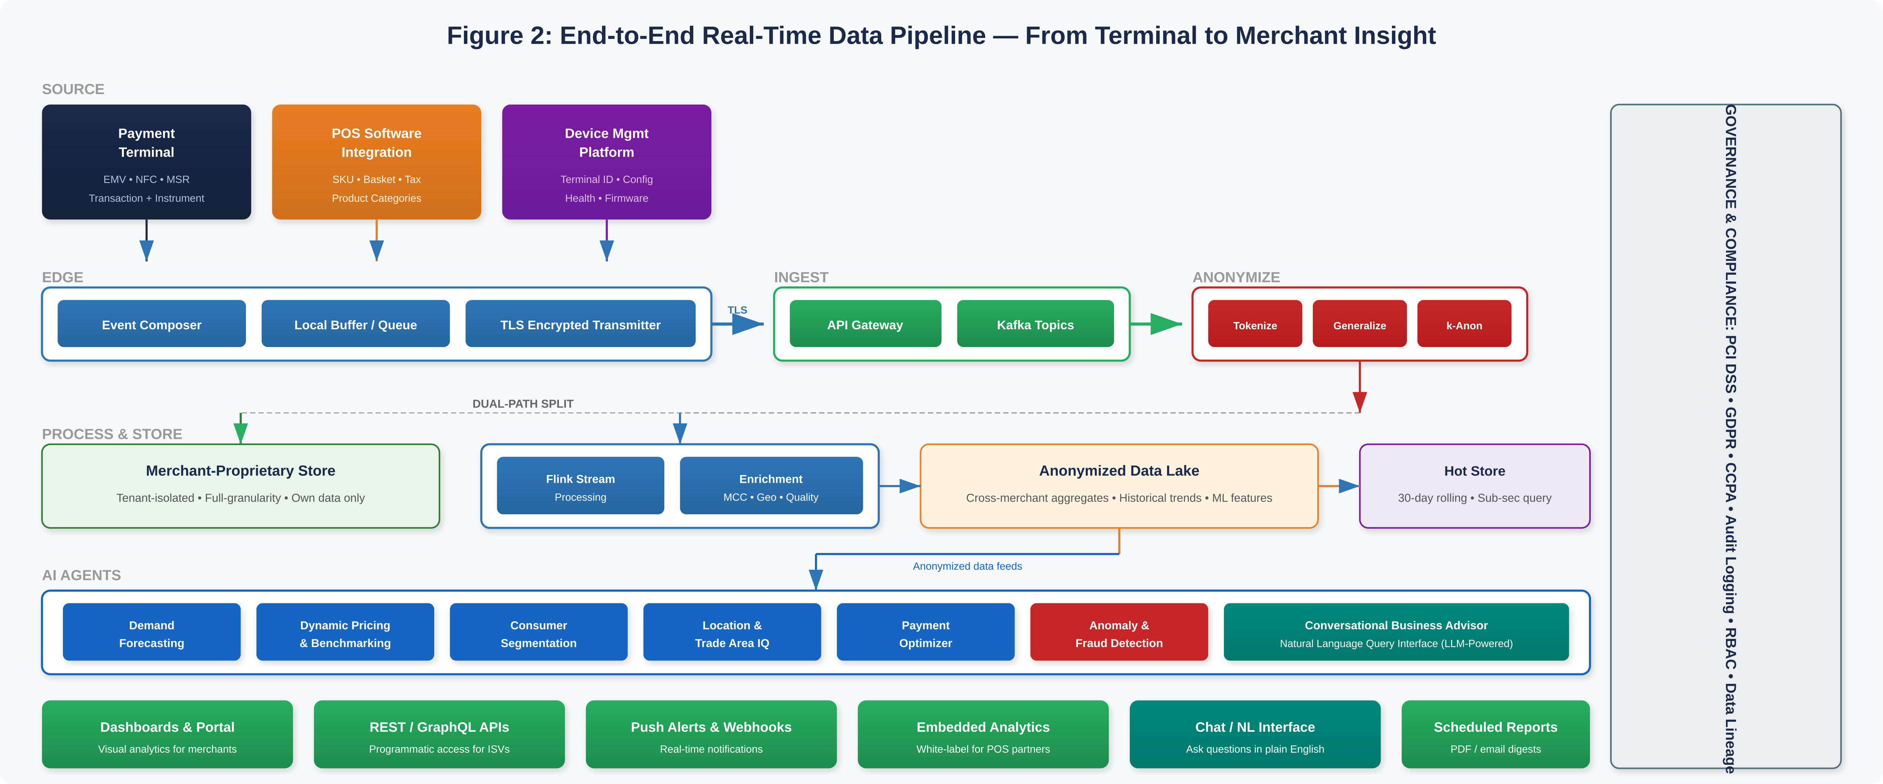
Figure 2: End-to-End Real-Time Data Pipeline — From Terminal to Merchant Insight

9.2 Latency Targets
The pipeline is engineered for the following latency targets at each stage:
Pipeline Stage | Latency Target (P95) | Design Mechanism
Device → Edge Broker | < 100ms | In-process event listener
Edge Broker → Cloud Ingest | < 5 seconds | Micro-batching, TLS keep-alive
Ingest → Anonymization | < 500ms | Flink operator chaining
Anonymization → Storage | < 1 second | Direct write to hot store
Storage → AI Agent Insight | < 3 seconds | Pre-computed features, incremental models
End-to-End (Device → Insight) | < 10 seconds | Streaming-first architecture

9.3 Scalability
The pipeline is horizontally scalable across all tiers. Kafka partitioning and Flink parallelism allow throughput to grow linearly with merchant volume. Multi-region deployment ensures low-latency ingestion globally and provides disaster recovery. A dead-letter queue captures failed events for remediation without blocking the primary pipeline.

10. AI Agent Deployment Strategy

10.1 Agent Architecture Overview
We deploy a suite of specialized AI agents that operate on the anonymized data lake and real-time event streams to generate continuous, actionable insights for merchants. Each agent follows a standardized four-layer internal architecture: data access, model inference, business logic/reasoning, and delivery. Agents are deployed as independently scalable containerized microservices.
The following diagram illustrates the complete AI agent architecture, showing how data inputs feed into each agent and how agent outputs map to specific merchant use cases and value propositions:

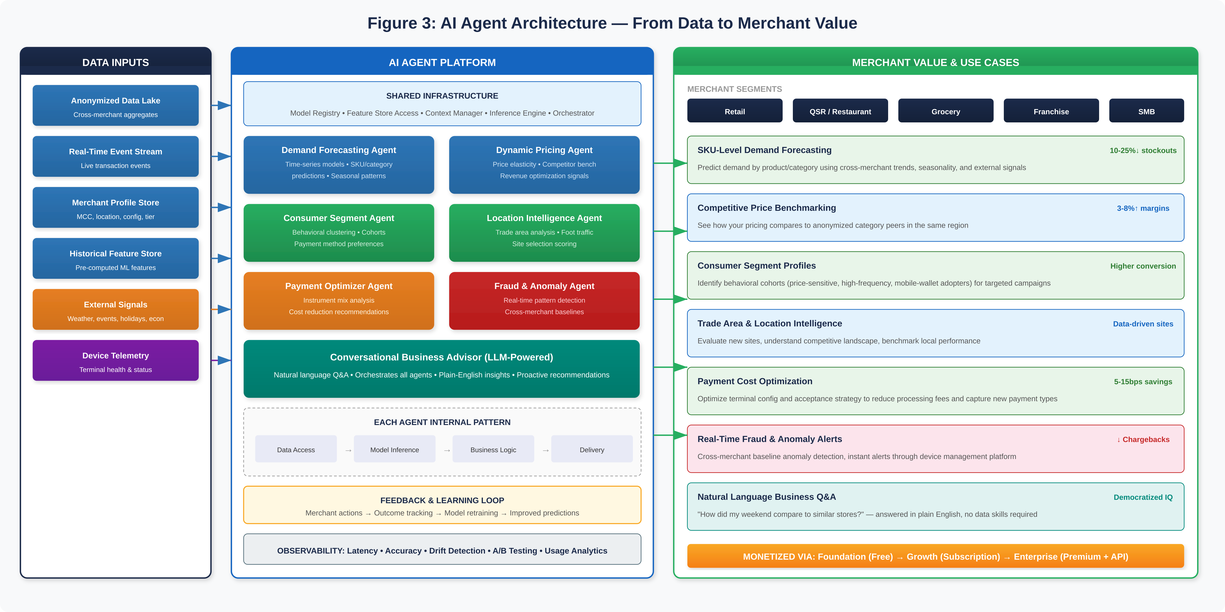
Figure 3: AI Agent Architecture — From Data to Merchant Value

10.2 Agent Descriptions
Demand Forecasting Agent
Analyzes anonymized transaction patterns across similar merchants to predict demand at the SKU and category level. Incorporates cross-merchant trends, seasonal cycles, day-of-week patterns, and external signals (weather, local events, holiday calendars). Generates forward-looking demand signals for inventory optimization.
Dynamic Pricing & Benchmarking Agent
Leverages anonymized basket data across merchants in the same category and region to provide pricing intelligence. Identifies price elasticity patterns, benchmarks a merchant’s pricing against anonymized category peers, and recommends pricing adjustments. Surfaces competitive dynamics such as new entrants or shifts in consumer price sensitivity.
Consumer Segmentation Agent
Identifies behavioral segments among consumers visiting a merchant’s category using anonymized, aggregated transaction patterns. Segments include price-sensitive shoppers, high-frequency buyers, weekend-only customers, and payment-method-specific cohorts (e.g., mobile wallet adopters). Delivers actionable segment profiles with engagement strategies.
Location & Trade Area Intelligence Agent
Synthesizes anonymized transaction density, foot traffic proxies, and merchant mix data to provide trade area analytics. Enables competitive landscape assessment, underserved category identification, new location evaluation, and peer benchmarking within a trade area.
Payment Optimization Advisor Agent
Analyzes payment instrument distribution across a merchant’s transactions versus category benchmarks. Recommends terminal configuration and acceptance strategy changes to reduce processing costs. Identifies digital wallet adoption trends and advises on terminal upgrade timing.
Anomaly Detection & Fraud Intelligence Agent
Operates in real time on the transaction stream, detecting anomalous patterns using cross-merchant baselines. Identifies potential fraud, terminal tampering, or unusual activity. Alerts are triaged by severity and delivered instantly through the device management platform.
Conversational Business Advisor Agent
A natural language interface powered by a large language model that allows merchants to ask questions in plain English. This agent orchestrates calls to all other agents, enabling queries like “How did my weekend sales compare to similar merchants?” or “Which categories are trending up this month?” to be answered in real time. Democratizes analytics for merchants without data expertise.

10.3 Feedback & Learning Loop
Each agent incorporates a feedback loop where merchant actions (e.g., accepting a pricing recommendation, reordering based on a demand forecast) are tracked as outcomes. These outcomes are fed back into model retraining pipelines, continuously improving prediction accuracy and recommendation relevance over time.

11. Merchant Use Cases & Value Delivery

11.1 Use Case Matrix
Use Case | Target Merchants | AI Agent | Value Delivered
SKU-level demand forecasting | Retail, Grocery, Convenience | Demand Forecasting | 10–25% reduction in stockouts
Competitive price benchmarking | QSR, Retail, Fuel | Dynamic Pricing | 3–8% margin improvement
Customer segment identification | All merchant types | Consumer Segmentation | Higher conversion rates
New location evaluation | Franchise, Multi-location | Location Intelligence | Data-driven site selection
Payment cost optimization | High-volume merchants | Payment Optimizer | 5–15 bps cost savings
Real-time fraud alerts | All merchant types | Anomaly Detection | Reduced chargebacks
Natural language analytics | SMB merchants | Conversational Advisor | No data skills needed
Seasonal planning | Retail, Hospitality | Demand + Segmentation | Optimized promo ROI

11.2 Cross-Merchant Insight Advantage
The greatest differentiation comes from insights only possible by observing patterns across merchants. No individual merchant can see how consumer behavior shifts between competitors, how regional trends emerge before reaching their location, or how their basket composition compares to category norms. Our anonymized cross-merchant data layer, combined with AI agents that synthesize these patterns, delivers intelligence that merchants cannot generate independently.

12. Data Products & Monetization

12.1 Tiered Product Model
Tier | Capabilities | Target Audience
Foundation | Basic dashboards, payment mix, daily summaries, fraud alerts | All merchants on platform (included)
Growth | Cross-merchant benchmarking, consumer segmentation, demand trends, payment optimization | Growth-stage merchants, multi-location (subscription)
Enterprise | Full AI agent suite, conversational advisor, API access, trade area intelligence, white-label reports | Enterprise merchants, franchises, ISVs (premium)

12.2 Revenue Channels
- SaaS Subscription: Monthly/annual fees for Growth and Enterprise tiers, priced per location or transaction volume.
- API Access: Consumption-based pricing for programmatic insight access.
- Embedded Analytics: White-label modules for ISV partners, generating revenue-share arrangements.
- Custom Reports: One-time or recurring analytical reports for large merchants or industry bodies.

13. Implementation Roadmap

Phase 1: Foundation (Months 1–6)
- Deploy Data Capture Module firmware update across terminal fleet.
- Implement POS API Bridge for top 5 POS platform integrations.
- Build cloud ingestion pipeline (API Gateway, Kafka, Schema Registry).
- Deploy anonymization engine (tokenization, generalization, k-anonymity).
- Launch merchant-proprietary dashboards (Foundation tier).
- Complete privacy impact assessment and PCI DSS scope validation.

Phase 2: Intelligence Layer (Months 4–10)
- Build anonymized cross-merchant data lake with differential privacy.
- Deploy Demand Forecasting and Anomaly Detection agents.
- Develop merchant-facing API and alert delivery infrastructure.
- Beta program: 50–100 pilot merchants for Growth tier.
- Expand POS integrations to next 10 platforms.

Phase 3: Scale & Differentiate (Months 8–18)
- Deploy remaining AI agents (Pricing, Segmentation, Location, Payment Optimizer).
- Launch Conversational Business Advisor (LLM-powered).
- Commercial launch of Growth and Enterprise subscription tiers.
- ISV partner program for embedded analytics.
- Multi-region cloud deployment for global terminal fleet.

Phase 4: Ecosystem Maturity (Months 15–24)
- Open API marketplace for third-party developers.
- Implement feedback loops for continuous AI model improvement.
- Explore federated learning and secure multi-party computation.
- Strategic partnerships with financial institutions and CPG brands.

14. Governance, Compliance & Risk

14.1 Regulatory Framework
Our data strategy must comply with PCI DSS (as a payments company handling card data at the terminal level), GDPR, CCPA/CPRA, and sector-specific regulations in each operating jurisdiction. A dedicated Data Privacy Office oversees compliance, regulatory change management, and merchant communication regarding data practices.

14.2 Governance Controls
- Data Ownership: Merchants retain ownership of proprietary data. Anonymized aggregates are derived assets under data processing agreements.
- Access Controls: RBAC with least privilege. All raw data access requires MFA and is audit-logged.
- Data Retention: Raw data per PCI DSS requirements. Anonymized data retained for trend analysis. Configurable merchant-facing retention.
- Audit & Transparency: Annual third-party privacy audits. Merchant transparency portal for data practices.

14.3 Risk Mitigation
- Re-identification Risk: Continuous adversarial testing. Automated suppression below thresholds.
- Model Bias: Regular fairness audits ensuring recommendations don’t disadvantage merchants by geography, size, or category.
- Vendor Risk: Cloud and third-party processors subject to security and privacy due diligence.

15. Success Metrics & KPIs
Metric Category | KPI | Year 1 Target
Pipeline Latency | End-to-end (device to insight) | < 10 seconds (P95)
Data Quality | Enrichment completeness rate | > 95% of events fully enriched
Anonymization | K-anonymity compliance | 100% of datasets ≥ k=50
Data Capture Coverage | Terminals with Data Capture Module active | > 90% of fleet
POS Integration | Basket data availability rate | > 70% of transactions with SKU data
Merchant Adoption | Active Foundation dashboard users | 60% of merchant base
Monetization | Growth/Enterprise tier conversion | 8–12% of eligible merchants
AI Agent Accuracy | Demand forecast MAPE | < 15% at category level
Merchant Satisfaction | NPS for data products | ≥ 45

16. Conclusion & Next Steps
This strategy and solutions document presents a complete blueprint for transforming our payments infrastructure into an intelligence platform. By instrumenting every layer of the technology stack—from the terminal hardware and OS, through the POS integration and edge-to-cloud transmission, to the anonymization pipeline and AI agent deployment—we create a data foundation that powers merchant insights no competitor can replicate.
The phased approach delivers early value through Foundation-tier dashboards and fraud alerts while progressively deploying AI agents that create a durable competitive advantage and diversified revenue streams. The privacy-first architecture ensures we can scale this capability across geographies and regulatory environments with confidence.

Immediate Next Steps
- Executive Alignment: Secure leadership endorsement and funding for Phase 1.
- Firmware Roadmap: Prioritize Data Capture Module development in the terminal OS engineering backlog.
- POS Partner Engagement: Begin technical integration planning with top 5 POS platforms.
- Privacy Impact Assessment: Commission formal PIA for the anonymization framework.
- Cloud Architecture: Finalize streaming platform and storage vendor selections.
- Team Formation: Staff Data Platform, AI Engineering, and Data Privacy Office teams.
- Pilot Merchants: Identify and engage 50–100 merchants for Growth tier beta.

END OF DOCUMENT

